**EagleDream Console Application – Technical Specifications**

**YOUR LOGO**

**EagleDream Console Application**

**Kevin May**

**December 17, 2020**

**Version 0.0.0**

| REVISION HISTORY | | | |
| --- | --- | --- | --- |
| DATE | VERSION | DESCRIPTION | AUTHOR |
| 12/17/2020 | 0 | Initial Creation | Kevin May |
|  |  |  |  |
|  |  |  |  |
|  |  |  |  |
|  |  |  |  |
|  |  |  |  |
|  |  |  |  |

Table of Contents

INTRODUCTION 3

Project Overview 3

Objective 3

Business Case 3

Risks 3

Out of Scope 3

Technical Design Diagram 3

Technical Specifications 4

Servers 4

Software 4

Installation 4

Access Requirements 4

Databases 4

Technical Contacts 5

Assumptions 5

Concerns and Issues 5

APPENDICES 6

APPENDIX A: GLOSSARY OF TERMS 6

APPENDIX B: ANALYSIS DOCUMENTATION 6

APPENDIX C: ISSUES 6

# INTRODUCTION

## Project Overview

EagleDream professionals would like a command line tool that helps them glean basic information from the data in their database. At a minimum, the command line tool will return the following:

* An outline of user’s account balances
* The year-to-date balance of each group
* How many transactions of each transaction type have happened per month

### Objective

The scope of this project is to deliver a product to the user that can be easily scalable at any given time. This project will deliver a product to the end-users that will assist in productivity. At this time, the output of the console application will return in a csv format that can be exported for further analysis.

### Business Case

The case for this project is to streamline the end-users day-to-day activity by providing the business an application to retrieve results from the master database.

### Risks

There are no know risks at this time.

### Out of Scope

Not applicable at this time.

## Technical Design Diagram

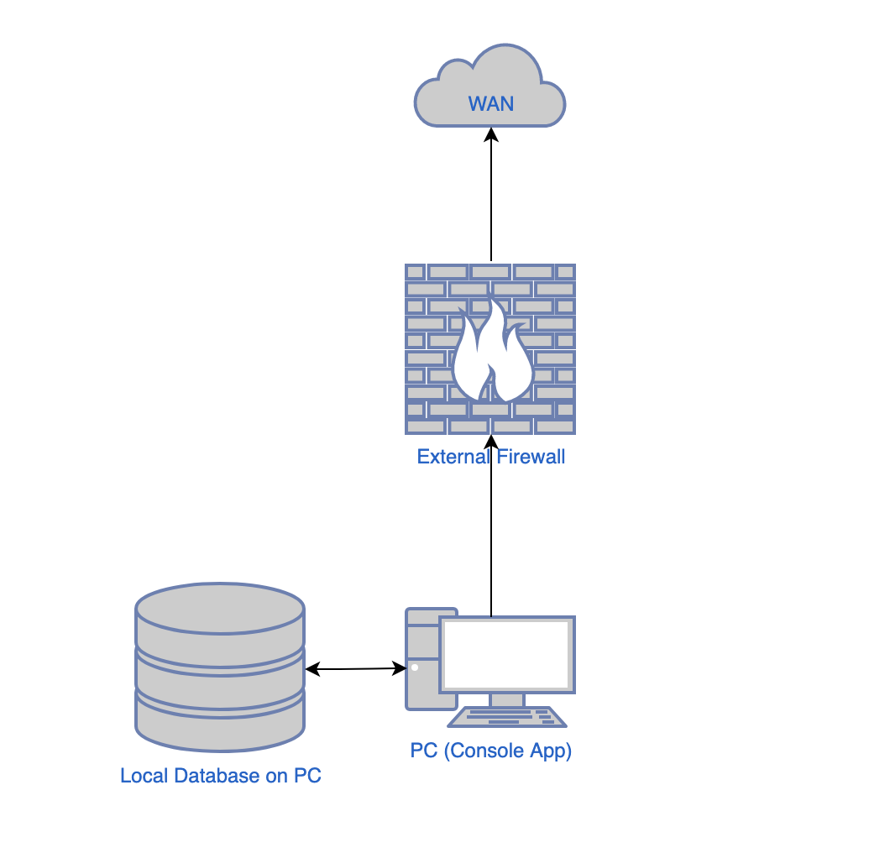

## Technical Specifications

### Servers

#### Application Servers

macOS Catalina version 10.15.7

3.2 GHz Quad-Core Intel Core i5

32 GB 1600 MHz DDR3

AMD Radeon R9 M380 2 GB

#### File Servers

Not applicable at this time.

#### Web Servers

Not applicable at this time.

#### Database Servers

macOS Catalina version 10.15.7

3.2 GHz Quad-Core Intel Core i5

32 GB 1600 MHz DDR3

AMD Radeon R9 M380 2 GB

### Software

Visual Studio 2019 for Mac

SQLite Flow

### Installation

Since this application will be executed locally only the following is required:

1. Open up the **eagleDreamConsoleApp.sln** file in Visual Studio 2019 for Mac
2. Locate **app.config** and update the **EagleDreamConnection** connection string that points to the **bank_km.db** database *(NOTE: database file has been updated, please make sure you are using the correct database)*

## Access Requirements

This application will be open to all users during the initial rollout. It is expected to have a total of 9 simultaneous users (12/17/2020) accessing the application.

## Databases

SQLite Database

Databases:

* group_membership
* group_type
* transaction_type
* user
* user_transaction

Views:

* vw_groupBalanceByMonth
* vw_groupTypeActive
* vw_groupTypeInactive
* vw_transactionCountByMonth
* vw_transactionTypeActive
* vw_transactionTypeInactive
* vw_userActive
* vw_userInactive
* vw_userTransactionsAll
* vw_userTransactionsTotalByMonthAll

## Technical Contacts

Kevin May – kevin.t.may@icloud.com

## Assumptions

No Assumptions at this time.

## Concerns and Issues

No concerns or issues at this time.

# APPENDICES

## APPENDIX A: GLOSSARY OF TERMS

KM: Kevin May

## APPENDIX B: ANALYSIS DOCUMENTATION

## APPENDIX C: ISSUES

List all unresolved issues, TBDs, pending decisions, findings required, conflicts, etc.

| ISSUES | | |
| --- | --- | --- |
| ID | DESCRIPTION | PARTY RESPONSIBLE |
|  |  |  |
|  |  |  |
|  |  |  |
|  |  |  |
|  |  |  |
|  |  |  |
|  |  |  |
|  |  |  |
|  |  |  |
|  |  |  |
|  |  |  |
|  |  |  |
|  |  |  |